**COFFEE SALES ANALYSIS**

This document provides a step-by-step guide to the creation of a sales analysis project for a coffee shop. It involves cleaning raw data, integrating details using Excel functions, creating pivot tables and charts, and building a dashboard for better insights.

**Overview of Workbooks**

The raw data consisted of three separate Excel workbooks:

**1.Orders Workbook:** This contained the raw order data, including:

|  |  |  |
| --- | --- | --- |
| * Order ID | * Order Date | * Customer ID |
| * Product ID | * Quantity |  |

**2.Products Workbook:** This contained details about the products:

|  |  |
| --- | --- |
| * Product ID | * Coffee Type |
| * Roast Type | * Size |
| * Unit Price | * Price per 100g |
| * Profit |  |

**3.Customers Workbook:** This included customerinformation:

|  |  |
| --- | --- |
| * Customer ID | * Customer Name |
| * Email | * Phone Number |
| * Address Line 1 | * City |
| * Country | * Postcode |
| * Loyalty Card |  |

*These three workbooks were combined to create a comprehensive orders table using Excel functions like VLOOKUP and XLOOKUP.*

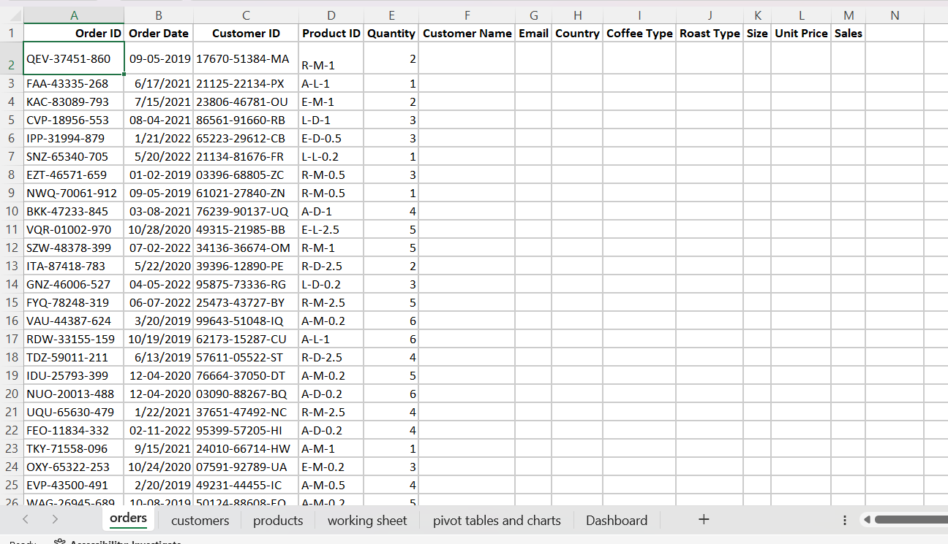

**Procedure**

**1.Data Cleaning and Preparation**The raw data in the Orders Workbook contained incomplete and messy information that required cleaning before it could be analysed effectively.

**Initial Challenges**

* Blank columns and missing data fields.
* Inconsistent formatting of dates and text.
* Duplicate values in key columns.

**Steps Taken**

* Removed Empty Columns:
  + Columns containing no data were deleted to simplify the dataset.
* Cleaned Data Using the ***TRIM*** Function:
  + The TRIM function was used to remove extra spaces from key fields (e.g., Product ID, Customer ID).
* Removed Duplicate Records:
* Highlighted the necessary columns (e.g., Customer ID or Product ID).
* ***Data > Remove Duplicates*** to eliminate duplicate entries.

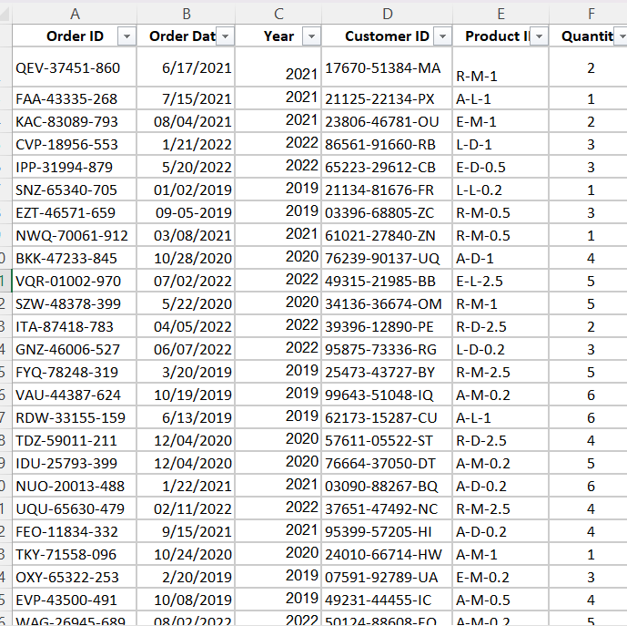

**3. Importing Data from Other Workbooks**

The next step was to enrich the **Orders Workbook** by importing relevant data from the **Products** and **Customers** workbooks for a comprehensive dataset.

**Steps Taken**

* Used ***VLOOKUP*** to Import Product Details:
  + Linked the **Product ID** column in the Orders table with the **Products Workbook** to fetch:
    - Coffee Type
    - Roast Type
    - Size
    - Unit Price
* Used ***XLOOKUP*** to Import Customer Details:
  + Linked the **Customer ID** column in the Orders table with the **Customers Workbook** to fetch:
    - Customer Name
    - Email
    - Country

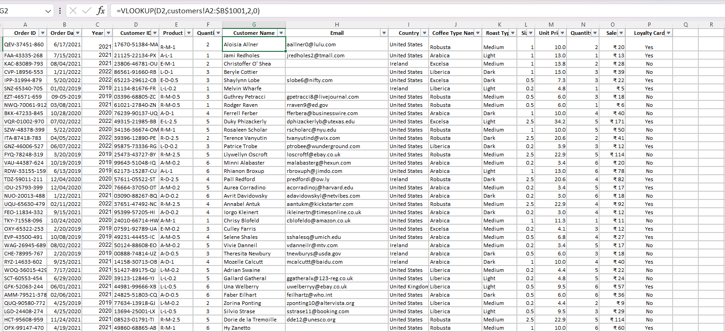

**4. Creating Pivot Tables and their Charts**

Pivot tables were used to summarize the enriched dataset and derive actionable insights.

**Steps taken to create Pivot Tables**

* Selected the enriched Orders table (working sheet)
* Navigated to ***Insert > PivotTable*****(Alt+N+V+T)** and placed the pivot tables in a new workbook (pivot tables and charts)
* Created the following pivot tables:
  + **Total Sales by Roast Type**: Summarized sales based on Coffee Type and Roast Type.
  + **Country wise customers**: Grouped sales by Country.
  + **Yearly Sales Trends**: Showed sales trends over time.
  + **Top Customers**: Highlighted the customers with the highest purchase volumes.

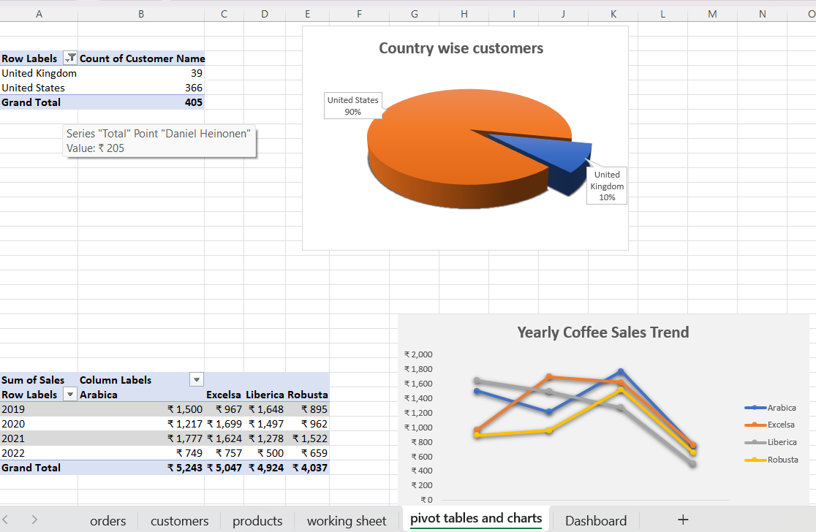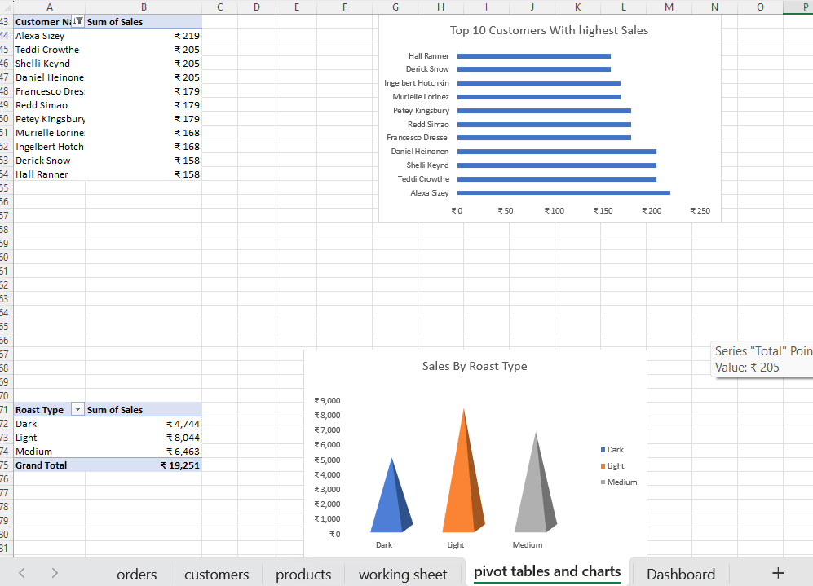

**6. Dashboard Creation**

**Objective**

To consolidate all the charts into a single, visually appealing dashboard.

**Steps Taken**

* Created a new sheet titled **Dashboard**.
* Copied and pasted all charts into the dashboard.
* Arranged the charts logically, ensuring titles and labels were clear.
* Added interactivity with slicers and applied conditional formatting for better visualization.

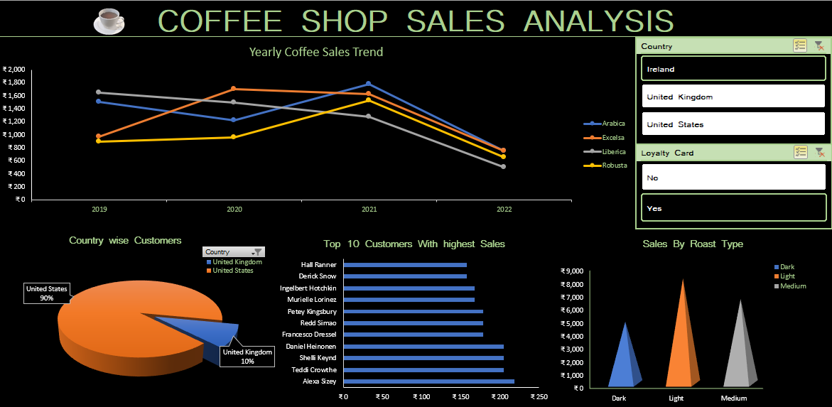

**INSIGHTS**

* Arabica consistently leads in sales, but all coffee types show a decline in 2022.
* United States accounts for 90% of customers, leaving growth potential in the United Kingdom.
* Dark roast has the highest sales, while Medium roast has the lowest, suggesting a need for targeted promotion.
* Top customers, such as Alexa Sizey significantly contribute to overall sales.
* The filters (Country and Loyalty Card) allow for further exploration of sales trends by region and customer loyalty.

**RECOMMENDATION**

* **Focus on Retaining Top Customers:** Provide exclusive deals or personalized offers to high spenders like Hall Ranner to maintain their loyalty.
* **Revive 2022 Sales Trends:** Introduce seasonal offers or promotions to counter the drop in sales in 2022.
* **Expand in the UK Market:** Increase marketing efforts in the United Kingdom to capture a larger share of this market**.**
* **Promote Medium Roasts:** Highlight the benefits of Medium roasts through marketing campaigns or bundling them with more popular items like Dark roast.
* **Analyse Loyalty Program Impact:** Use the loyalty card filter to identify if loyal customers spend significantly more and refine the program accordingly.